***White teddy bear with bow***

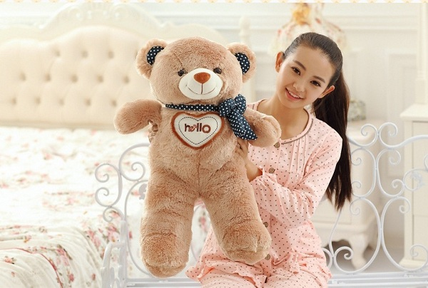

*A white teddy bear with a bow is very suitable as a girlfriend's birthday gift, a gift for a lover on her birthday, March 8, ..."*